Different spaces serve different purposes and therefore have different needs. We will look at the more popular types and kinds of spaces and consider what is essential for each space when planning our scheme.

## **Entrances**

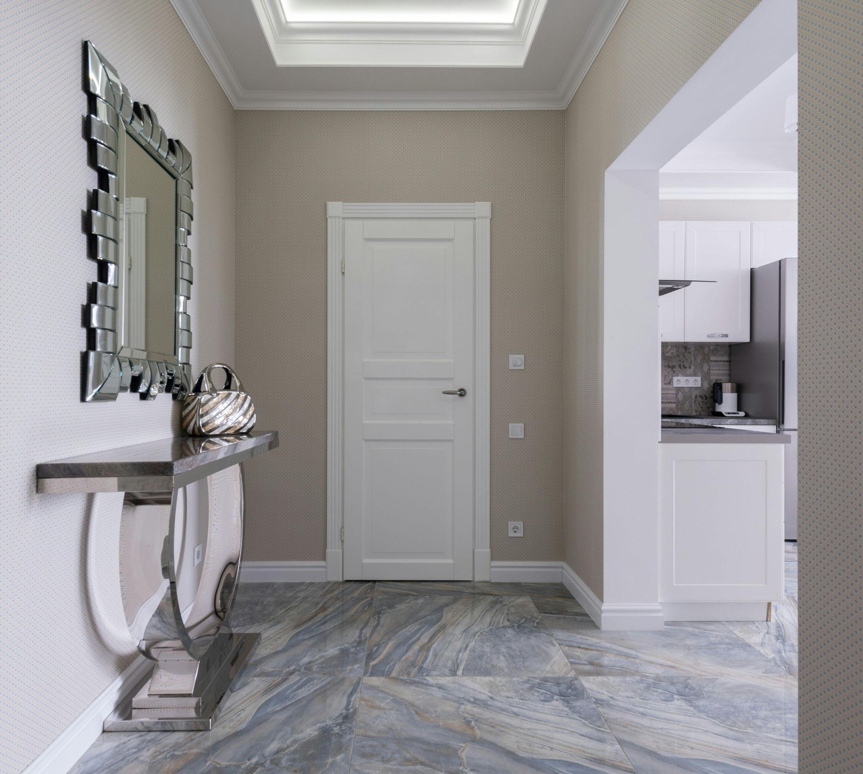

Fig 1. Unsplash (n.d.) Entrance hall

The entrance is the first room all visitors will see. Often, the entrance is ignored and can unintentionally create a cold, untidy and unfriendly atmosphere. Instead, the entrance should be the starting block for the decorating style you wish to create.

Considerations such as good lighting, a warm, welcoming feel, a colourful rug on the floor, a wall mirror or console for keys underneath, and a place for coats and umbrellas are aspects to keep in mind. Consider also:

* Where will coats, keys, umbrellas, and shopping bags be left?
* What flooring will you use that will be practical? As people may enter with wet or dirty footwear, the flooring must be durable and easy to clean

It is important not to clutter the hall with bric-a-brac and ensure plenty of space to walk through. Good lighting is also essential to give a bright impression when entering a room.

## **Stairs and landings**

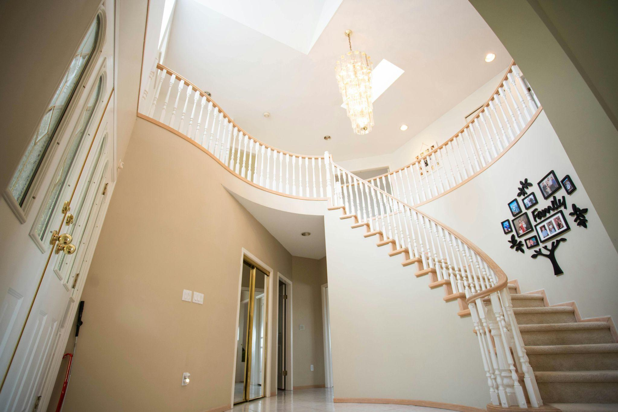

Fig 2. Pexels (n.d.) Staircase

Stairs can be an excellent feature element. Being the link between the different floors and usually positioned in a central location, their potential to create a feature is enormous. There are several possible layouts of stairs, starting with one flight of steps leading from one floor to another. Stairs can also have two or more flights broken up by landings on the way up.

Spiral staircases can be helpful when only limited access is needed, such as an additional room in the attic. Individual solutions such as fold-out stairs might be used for very restricted spaces.

## **Technical terms**

Stairs are constructed of a flight of steps leading from one floor to another. These are constructed by either running a flight of steps straight up or with landings on the way up.

The following are some technical terms associated with staircases:

* **A treat (going)** is the horizontal upper surface of the step on which you place your foot. This is a horizontal measurement
* **A riser** is the distance from tread to tread and is a vertical measurement
* **Flight** is the name given to each set of steps. For example, if your stairs go straight up from the ground floor to the first floor, without landings, this is one flight. If there are two small landings in between, you have three flights
* **Nosing** is the rounded part at the edge of each tread
* **The string** is the angled board at either the outside or inside of your stairs, supporting each end of the treads and risers. It is called a cut (or open) or closed string. A cut string is when the sides of the steps are open, and a closed string is when the sides of the steps are closed
* **Pitch** is the angle of your stairs
* **The balustrade** is the protective side of your stairway
* **Spindles** are the poles that make up the protective sides of the balustrade
* **The handrail** is the rail that holds the spindles in place. It is also used on the wall if the stairs are wider than one metre or if there is no balustrade required
* **Newel posts** are the posts that support the handrail at the top and bottom of the stairs and on the corners

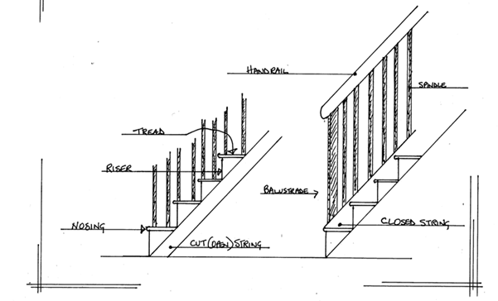

Fig. 3. Technical terms associated with staircases

Safety is paramount in designing and constructing your stairway, and it is necessary to be aware of applicable regulations.

* Sixteen steps per flight of stairs are the maximum allowable
* Headroom should not be less than 2m
* The riser must measure a maximum of 220mm. The optimum measurement is 175mm
* The going should be 220mm minimum. The optimum measurement is 250mm. More comfortable or external steps can go up to 300mm. (There should be a 3mm maximum variation from one step to another.)
* The pitch must have a minimum angle of 35° and a maximum slope of 42°. A good rule of thumb is that 2 x risers + 1 Going = 630mm. This is achieved, for example, for stairs with a Riser of 170mm and a going of 290mm and results in very comfortable stairs
* The average width of stairs is 900mm, but it is allowed to be 800mm, which is pretty narrow
* An ordinary domestic staircase of less than 1000mm must have a handrail on one side. More than 1000mm requires two handrails
* Landings must be available at the top and bottom of the stairs, with 400mm of space to avoid the swing of any door opening onto the landing
* Open-sided stairs are not allowed, and a balustrade must be provided. It should be constructed in such a way that children cannot climb it. This means that all spindles must be vertical, at least on the landings where they would make a handy ladder!
* Spindles must be less than 100mm apart. A ball of 100mm should not be able to pass the balustrade at any point
* The minimum height of the balustrade must be 850 mm on the stairs and 900 mm on the landings

## 

## **Living room**

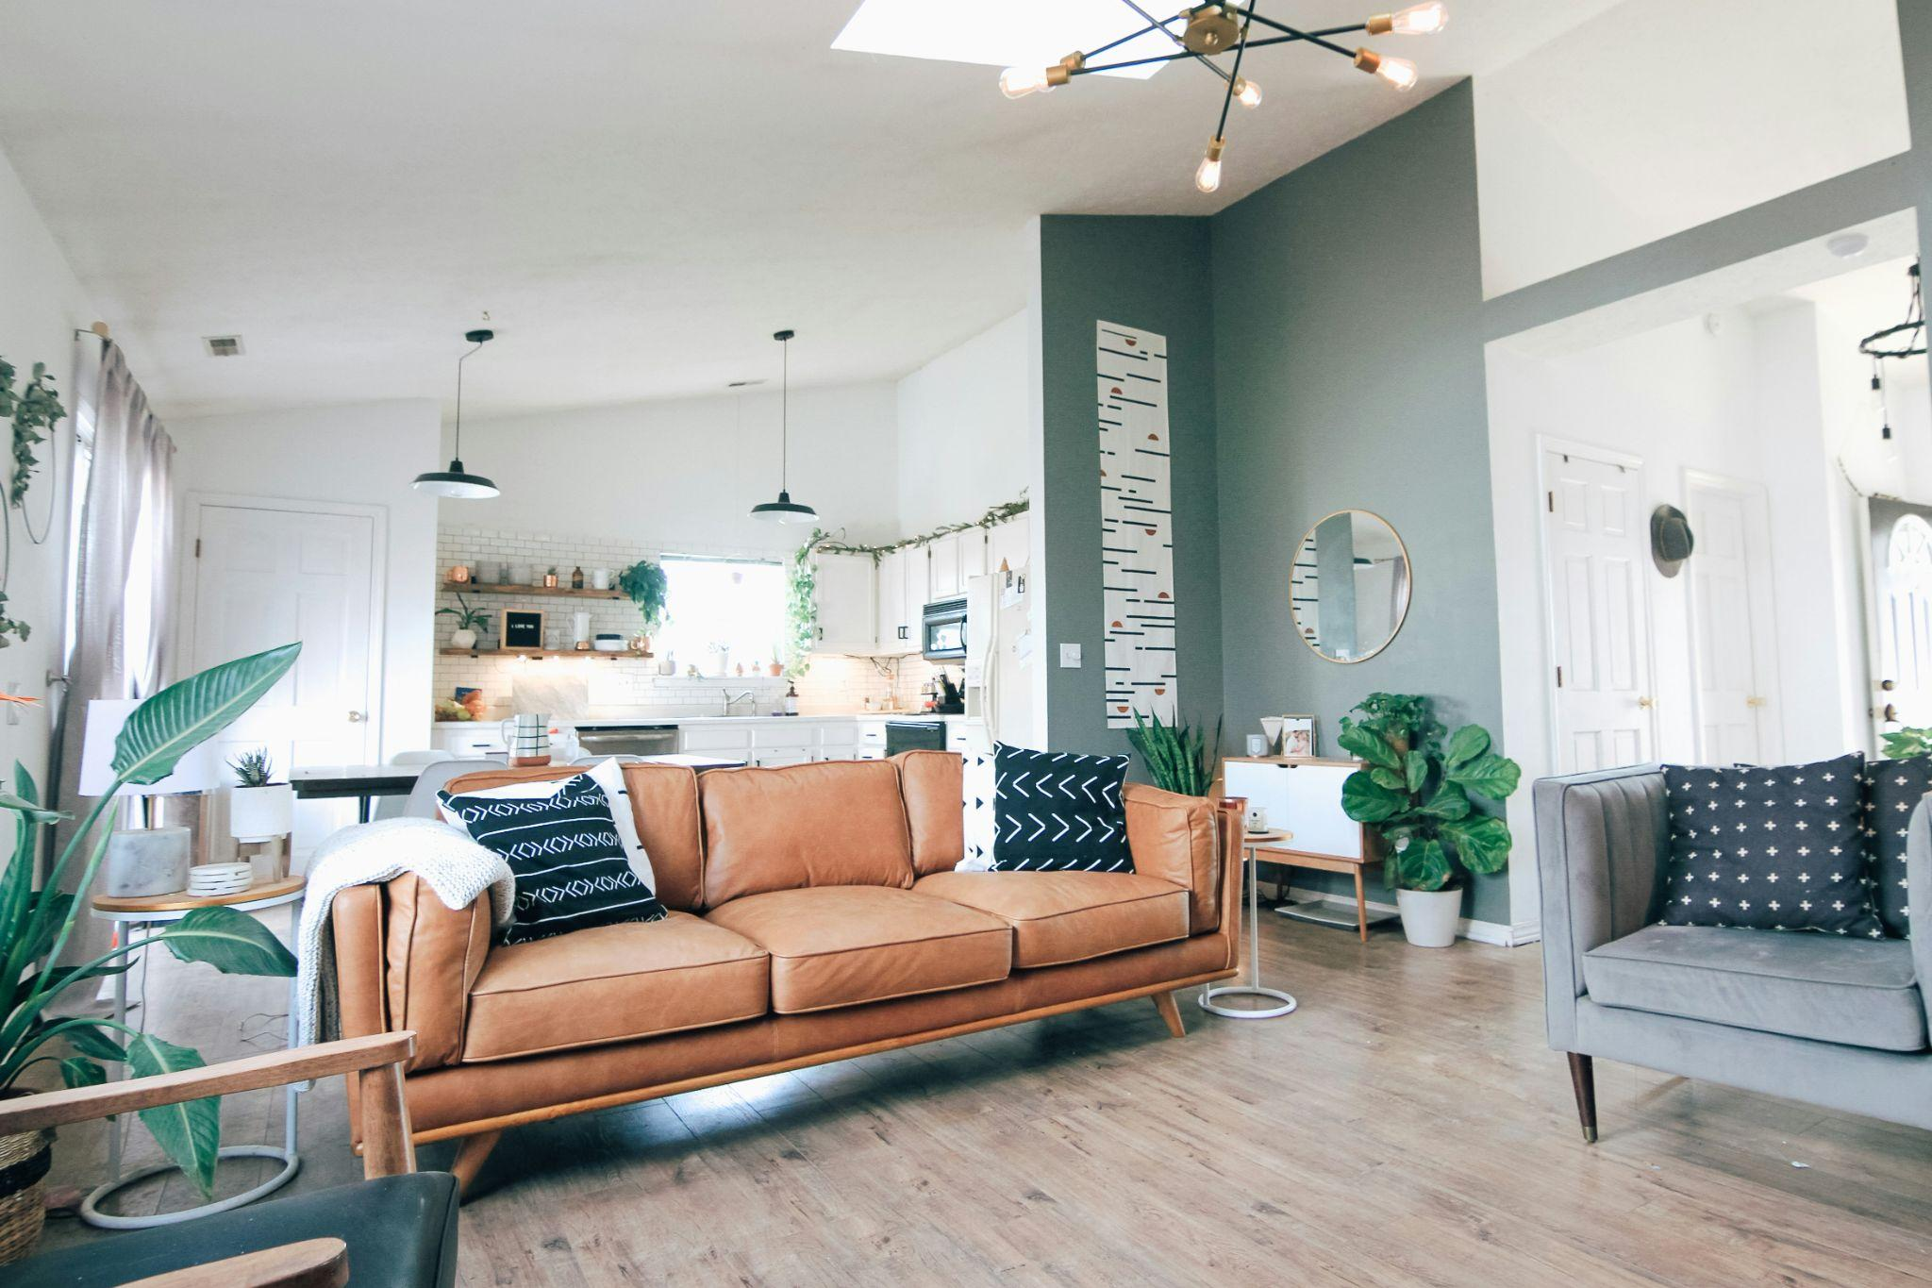

Fig 4. Unsplash (n.d.) Living room

The living room should be welcoming and comfortable. This is a space which is often used. Remember that the living room should reflect the person’s unique lifestyle.

When decorating the living room, remember to ask yourself the following questions:

* What will this room be used for?
* Is it a ‘front room’, or will it be used daily?
* Will it be used for entertaining?
* How many people must it be able to seat comfortably?
* What age group will it need to accommodate?
* Should it be formal, smart-casual or casual?
* Will there be a television?
* Will bookcases be necessary, or is there a particular collection that needs housing?
* Is it a quiet room for listening to music or reading—away from the bustle of the rest of the home?
* A room for studying or using the computer?
* A room that combines a dining area?
* All or most of the above?

The primary function of most living rooms is to sit and talk, watch television or read. It is essential to arrange living room furniture with these activities in mind. For chatting or watching TV, we need to think about furniture in relation to other furniture. The positioning of furniture can be complicated. Start with the main grouping first; several symmetrical arrangements look great in a living room.

For reading, sewing, or other solo activities, we need to consider furniture placement in terms of lighting and comfort. Finally, knowing that many people will enjoy a drink or a dish in the living room, we must also provide for their needs.

Do not be afraid to create separate areas within the room that can be coordinated for the variety of activities which may take place. A desk to allow for work, a separate, cosy reading chair with a lamp and an ottoman can be placed away from the television area, affording some privacy. Additional seating can be an ottoman (footstool), which can be used as a coffee table or pushed into a bay window when not required. Small stools pushed under a large coffee table are also an excellent idea. Some extra dining chairs arranged against the wall can also be used. Remember to arrange your main seating areas before positioning the remainder of your furniture.

These kinds of extra areas allow the space to be comfortably used by more than one group of people involved in more than one activity while still creating a sense of togetherness and unity;

## **Kitchens**

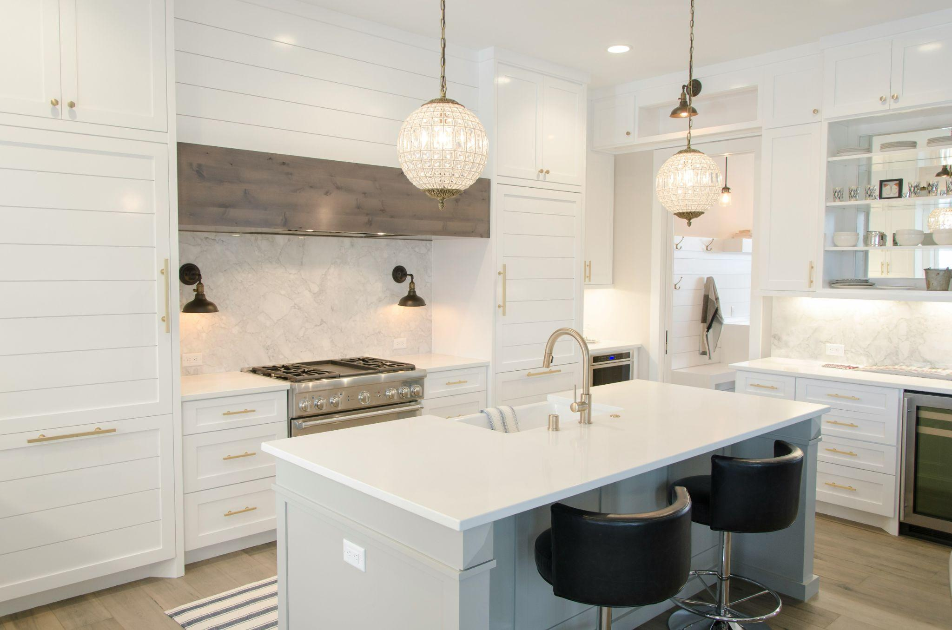

Fig 5. Unsplash (n.d.) Kitchen

It is important to emphasise that it is necessary to have the kitchen layout designed to suit the particular requirements of those who will use it. For example, is this a holiday let or a family home? Think of the number of electrical appliances used and always plan for a sufficient number of sockets in the kitchen.

An intrinsic part of kitchen design, the work triangle comprises your kitchen's three main working areas: your sink (water source), cooking appliances, and food storage (fridge/larder). The distance between these three areas should be as short as possible to promote efficiency and keep walking distances to a minimum.

When planning your kitchen layout, remember that your work triangle should ideally not be bisected by a thoroughfare. This is especially important when there are small children in the house. Again, this is not always achievable if the existing space doesn’t allow it.

Keep in mind that cooking is the primary function within this space. The design must reflect this, and the food preparation area must be prioritised. As mentioned above, the work triangle helps one organise the space into functional areas. When you use the kitchen, you constantly circulate between these areas; therefore, the flow between these areas needs to be appropriately considered.

Many homes are now built with the dining area as an integral kitchen instead of a separate ‘formal’ dining room. The kitchen/dining room is now, more or less, the norm and is even used to entertain friends. Each area should be designed to fulfil its function best and give the desired atmosphere. Of course, the design scheme should tie these areas together as they are in one visual space.

Lighting is also essential in the kitchen. You do not want to work in your own shadow, so effective lighting must be used.

## **Dining room**

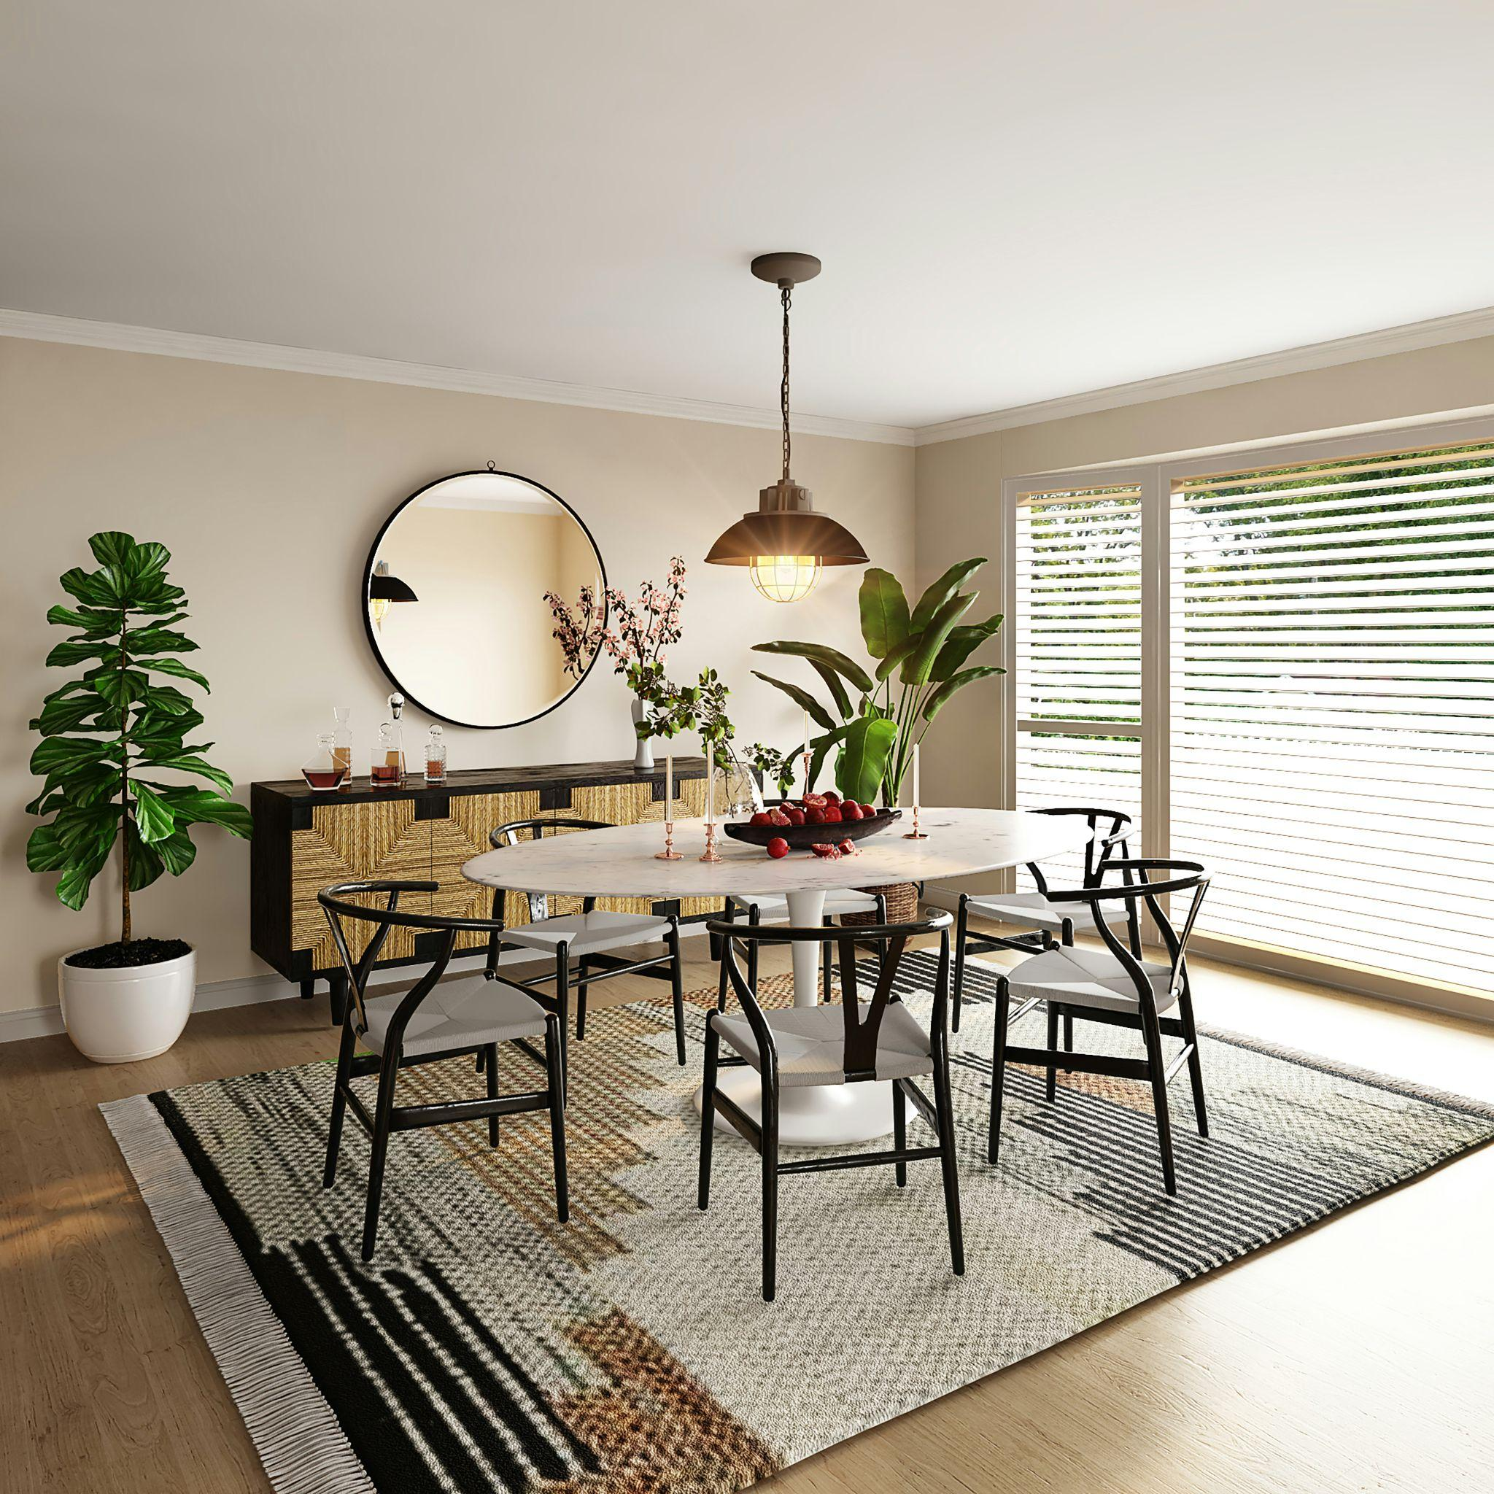

Fig 6. Unsplash (n.d.) Dining room

The dining room's colour and design depend on whether it is incorporated into the kitchen area or is a room to itself. In the past, this space would more often than not be more formal. However, today we often see this space integrated into open-plan areas like the kitchen.

When designing a dining space, it is vital to understand the client's lifestyle to appropriately meet their functional needs in terms of space and size needed for the dining space.

Ask the following questions:

* How many people will use the dining room regularly? How often is this space used?
* Will it be for formal entertainment?
* Will it mainly be for family and friends?
* What mood is it desired to create? Romantic? Minimalist?

Understanding the above will aid in deciding the size, shape and number of seats required for the dining space. It will also dictate if the client prefers an open-plan area or a dedicated formal dining room.

## **Studies/home office**

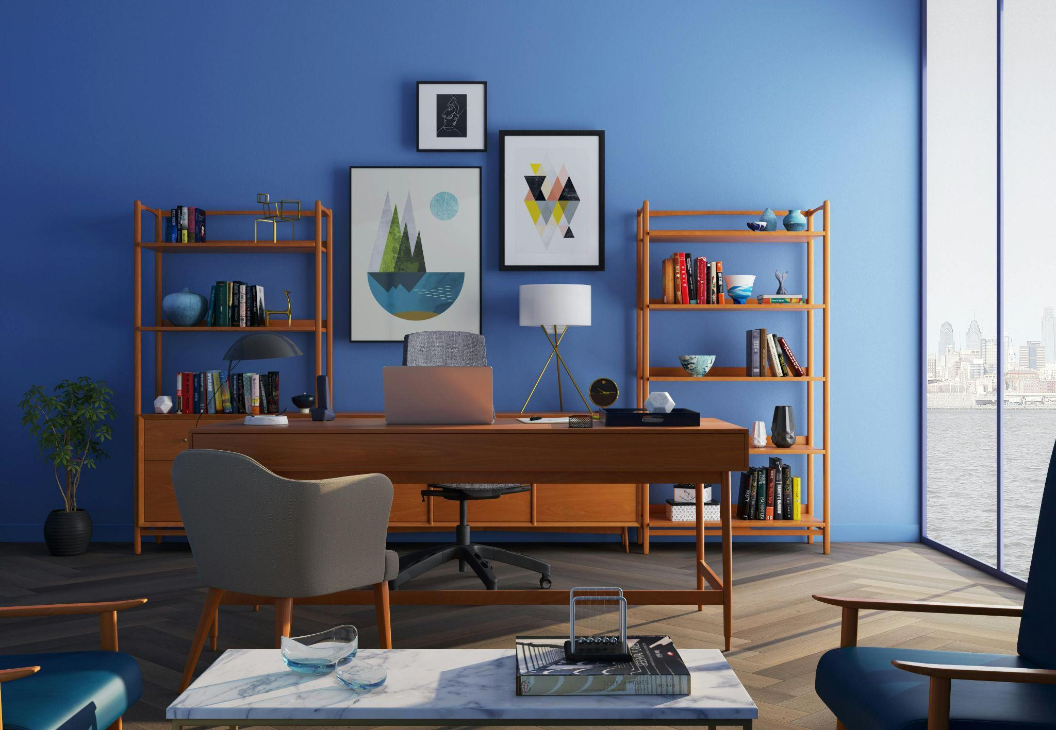

Fig 7. Pexels (n.d.) Home office

Because of their general similarities, most of the considerations needed when designing a living room also apply to the design of a study. The main difference between the two rooms is the kind of activity typically involved. Unlike the living room, only one person may use the study. Alternatively, it could be used by more than one person too. If the study is meant as a personal workspace, it is essential to tailor the space to that person’s needs. This includes the necessary furniture, comfortable seating, storage, adequate space for electronics, and the position within the home, i.e. would it be essential to be placed in a quieter area?

## **Bedrooms**

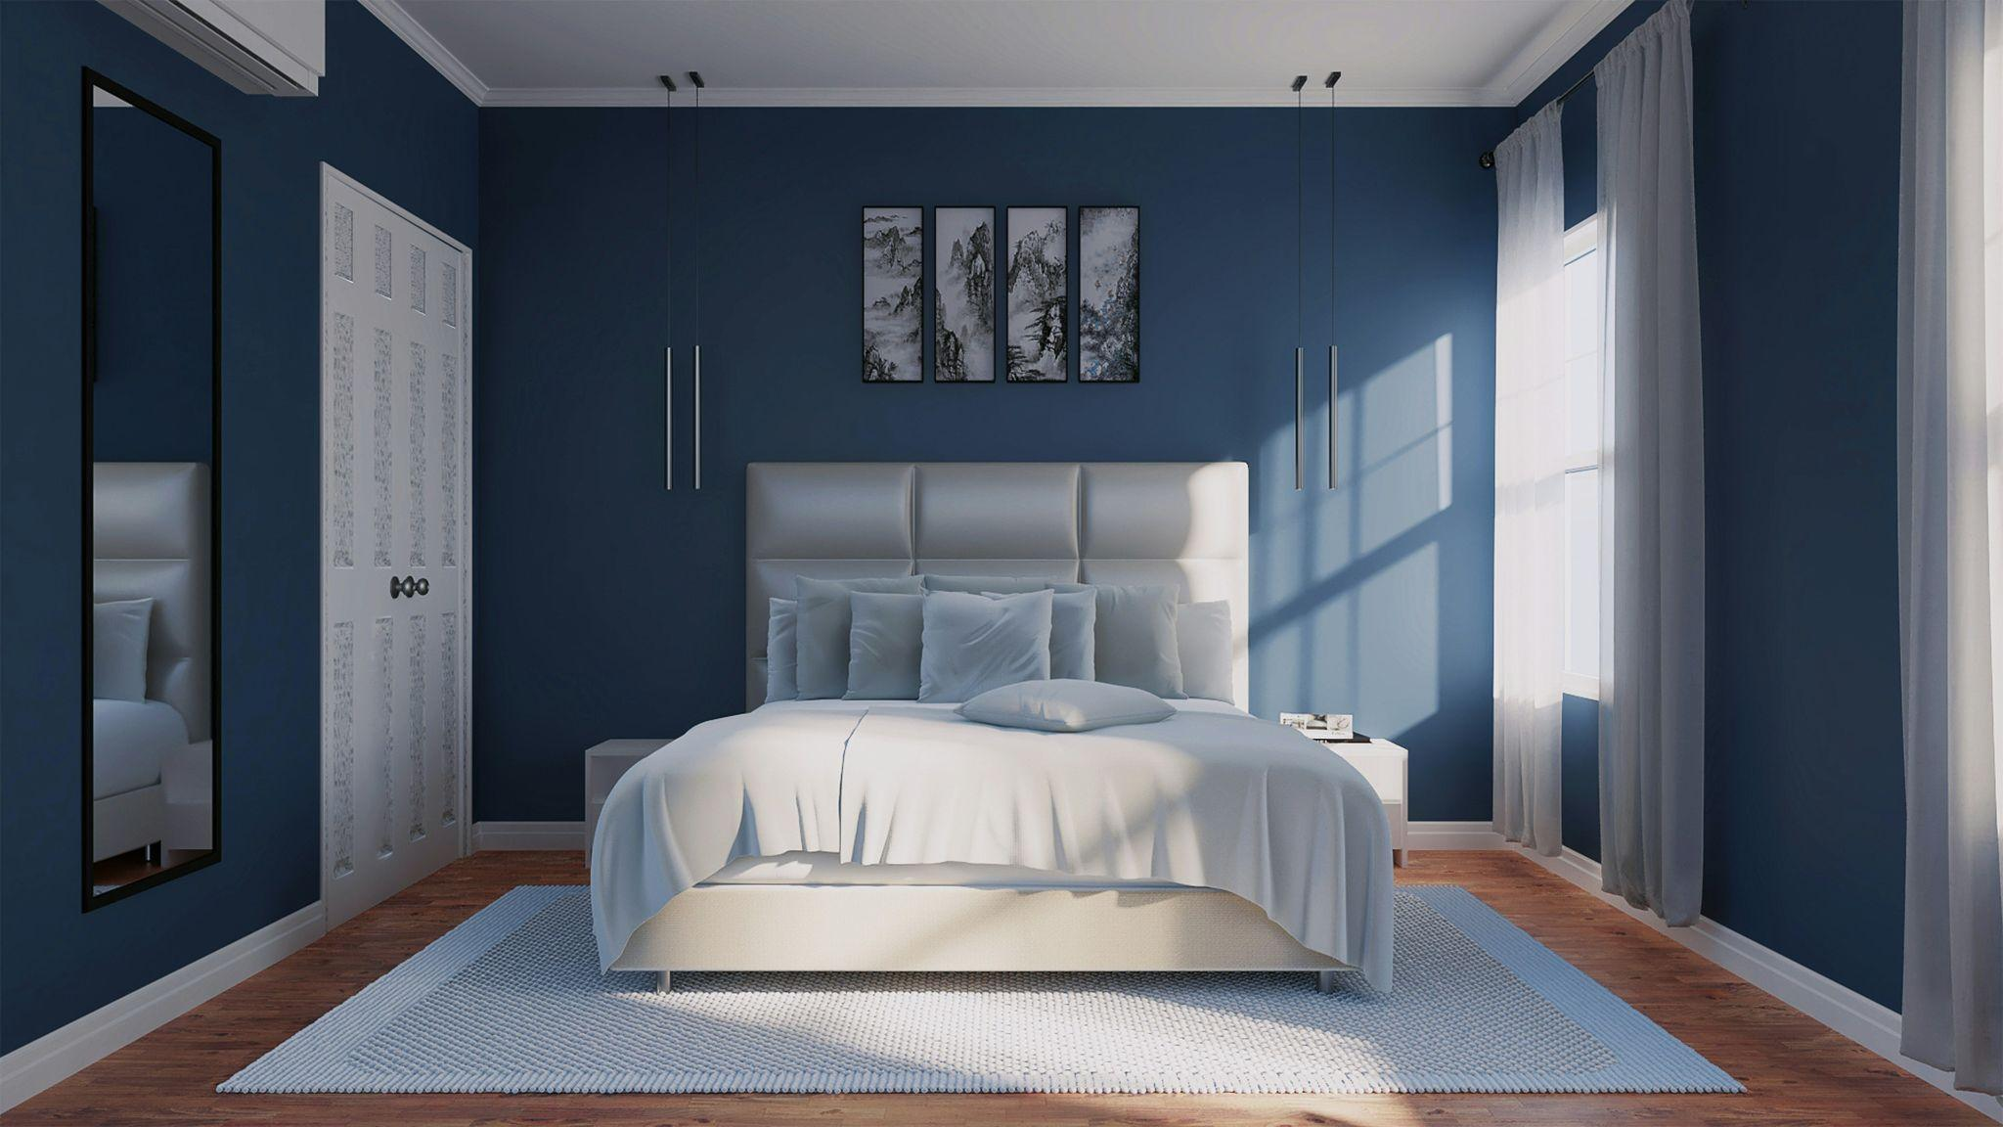

Fig 8. Unsplash (n.d.) Bedroom

The decoration of the master bedroom can pose challenges. For couples, it must accommodate a combination of male and female styles. The master bedroom is usually best decorated in a relatively neutral or monochromatic colour scheme (variations of one colour). This is both restful and uncontroversial. As the interior designer, it will be up to you to identify which style best suits your clients’ requirements and tastes.

Regarding the bed, many people love a padded headboard, especially those who love to read at night. So, what are the alternatives when it comes to choosing a headboard? Not everyone reads or watches TV in bed at night, so sitting up comfortably is not necessarily a priority in their lives. Brass or wrought iron bedsteads look wonderful but need lots of pillows, a bolster, and a few neck pillows to make them truly comfortable.

Cane and rattan headboards are also trendy. These usually come in a dark or pale varnish but can be colour-washed in a gentle shade to match the colour scheme in the bedroom, if necessary.

An oak or maple bedroom suite can achieve a more formal look. Well-designed furniture should have clean lines, and a headboard in a modern house does not need to have as many whirly designs as this contradicts a modern style. Where space is lacking, consider beds with integrated storage. Last but not least, there are ultra-modern headboards with technology integrated into the design.

To fully understand the functional and aesthetic requirements of the space, consider the following:

* Is it the master bedroom?
* A guest bedroom? If so, will it be used by older people?
* An occasional guest bedroom?
* A child’s bedroom? A teenage bedroom? If so, for a boy or girl?
* Will it be used for more than just sleeping (for example, studying, reading or watching television)?

Storage is also an integral part of the design of a bedroom, and the amount required will be dictated by the type of bedroom as well as the user of the space.

## 

## **Patios**

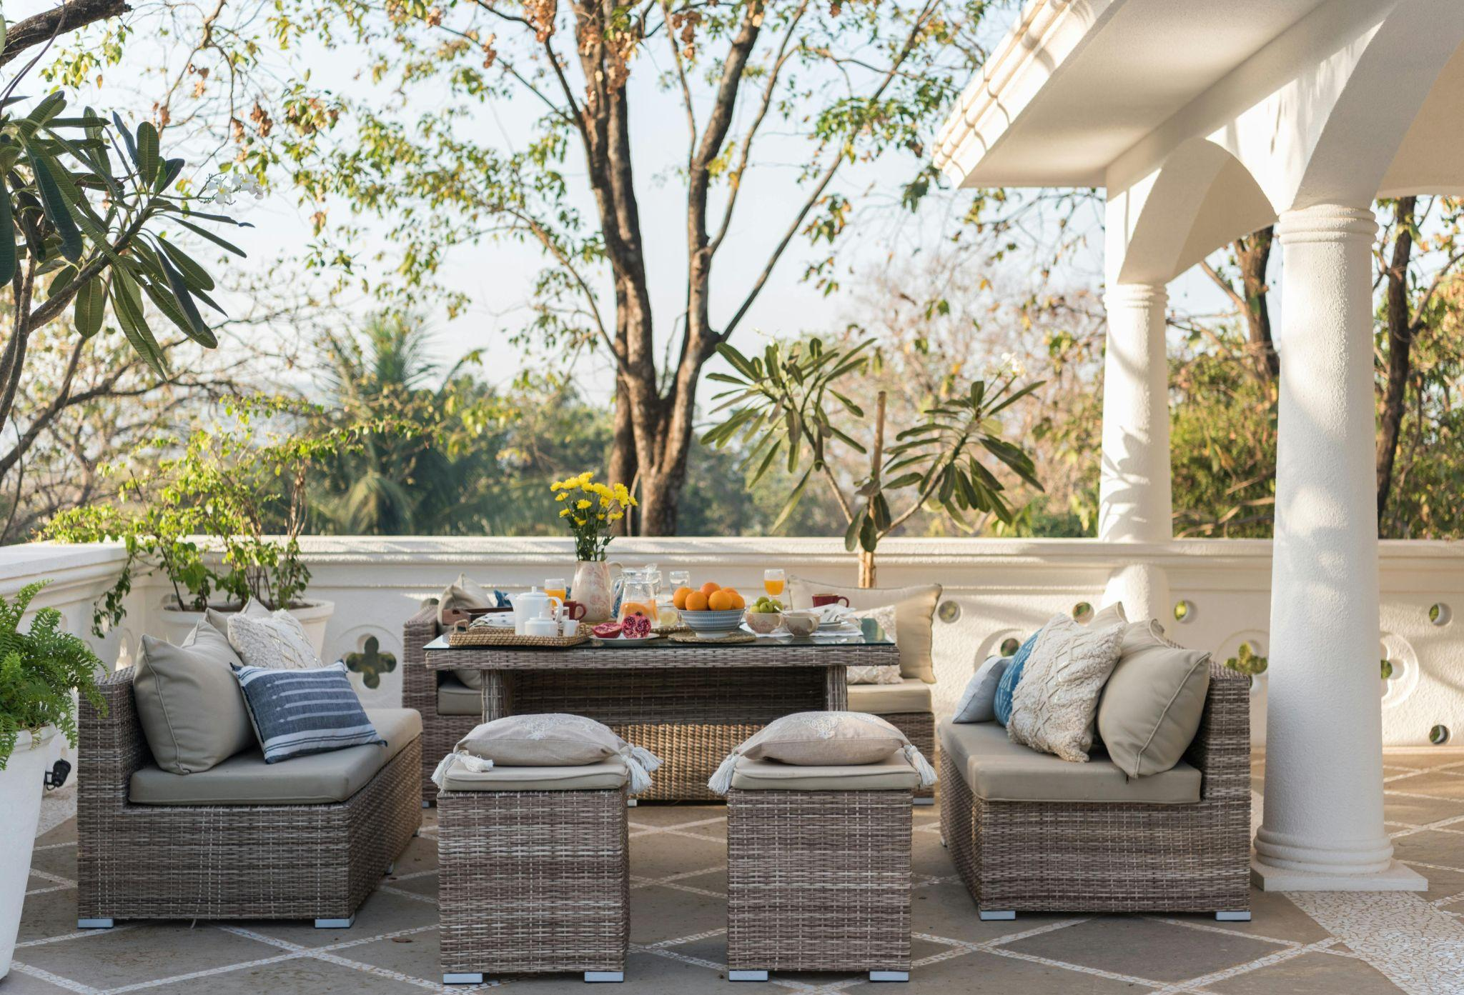

Fig 9. Pexels (n.d.) Outdoor patio

As with any space, understanding the requirements is vital. Will the patio be formal or informal? Will it be meant for personal seclusion or entertaining guests? Will it have a theme? If so, what theme? Is it easily viewed from an interior room?

The design of an exterior patio also needs to take functionality into account, with appealing arrangements of furniture and other items. Focal points, space for walking and modular areas are just as necessary in this area as anywhere else. Is there a beautiful tree? A stunning view? Remember that these kinds of things can serve as focal points.

Outdoor furniture is easily found, comes in several different styles, and is made with several other materials. The cheapest, of course, is plastic. While the thought of plastic furniture might turn you off, you can source high-quality furniture, which can be quite an attractive and budget-conscious option. Teak and other woods make excellent patio furniture, which can weather into a beautiful patina. Cane, rattan and wicker are other options, although they must be protected during winter. Coated metal is another quite desirable option. Whatever you choose, keep in mind the amount of exposure to weather that your furniture might have.

## 

## **Tips when designing the space**

It is vital to consider the location, use and architecture of a building, as doing this will help us get started and give us important hints for the design of each room. For example, it is essential to know which rooms face south and which face north to choose colours that will help brighten the rooms where needed or create coolness for spaces that might get too hot. Small rooms will require a different treatment to treatments given to spacious ones; low rooms are different to high ones.

### Furniture arrangement

The first thing that will come to mind is furniture. This is a good starting point as furniture will take up space and will most likely be the most important aspect of any room. It is used, noticed, and needs to ‘work’ for a design to succeed.

Are your clients party animals with an extended family or solitaires? When planning furniture, we should consider how many people might occupy the space so we can adjust for sufficient seating and storage space.

How will people circulate in the room? Can they easily reach their destination without having to circumnavigate items of furniture?

Generally, when considering furniture placement for any room, remember that furniture arrangements and groups forming an individual arrangement should be defined clearly and separated by enough space to delineate them and allow easy access. Having a separate reading area in your living room is excellent, but if the arrangement is so squashed that your thigh can barely fit through the space between the sofa and the armchair to access the area, you need to forget it. No one should ever need to move any furniture within a room to do what they need to do or reach what they need to do.

Also, remember that all furniture in a room should be arranged in a pattern or group. Do not place random pieces of furniture haphazardly. Pieces should always form a square or rectangle, a circle, an L or U, or even a straight line, but having discordant placements would be confusing and not pleasing to the eye.

When arranging the furniture, look at the walls, windows, and doorways, and try first to organise your furniture within its group and then this group arrangement within the layout of the room. Do not fall prey to the common misconception that the centre of a room should remain clear. This is simply not the case. If the centre works, then use it.

The essential thing to do is to try multiple designs. Exhaust the possibilities until you find the one most suited to your client’s needs, and that works best (keeping in mind line, form, style, etc.) aesthetically, functionally and architecturally.

### Considering colour

The colour scheme should, of course, be suited to the client’s taste. It should also advance any design themes you have in mind for the room.

When considering colour, think about what colours you want to put where. In small rooms that ish to make seem larger, be sure to paint or paper the walls with a lighter colour.

Darker colours will have the opposite effect. Suppose your client needs to place many colourful objects in the room, such as a collection of memorabilia. In that case, you might consider decorating in base colours such as white, cream or black and allow the objects alone to add additional colour. Other accent pieces, such as house plants, pictures, small decorative vases etc., can also be considered at this point, both in terms of colour and in terms of filling the room with the right or desired amount of accessories.

Many people fear the ‘institutional’ feel of white walls. This might be because many rooms in institutions are usually painted white. However, institutions use such a colour for the same reason you might consider doing so—it is so easy to work with. If a white-walled room makes the room feel cold, then there is not enough contrasting colour in the shape of design objects or furniture to provide the desired warmth. White can easily go from ‘institutional’ (a negative feeling) to clean and crisp (a positive feeling) with the proper use of additional colour. Keep this in mind when thinking of a colour scheme.

Remember, too, that colour is the way to brighten up and excite an all-white room. Pastels produce a soft and harmonious feel, while the presence of bright colours will make a white space come to life with minimal effort. Alternatively, to get rid of the neutral sense while not opting for an introduction of a specific colour or colours, just bring in greenery in the form of potted plants and flowers. These will have this effect. Potted plants and flowers can be pretty effective.

### Accessorising

Regarding accessorising, it might be good to consider the walls as the canvas (at least to start). Walls tend to look empty if not decorated. We should be careful to take advantage of this space because much can be done with it. The hanging of paintings and mirrors is an option, but what about installing built-in shelves, a bookcase or a cabinet with glass doors and a light inside? These can be used for everything from books to small knick-knacks or perhaps for a combination. Such pieces will display their wares at eye level, thus occupying empty wall space.

In particular, built-in shelving that takes up a whole wall is very effective and is an excellent filler for large rooms. In small rooms, it might be helpful only to use shelving that does not extend over the height of our eye level. This will help to make the space appear bigger and airy.

A few guidelines might be helpful if opting for the more traditional wall decorations. Remember that portraits are best hung facing towards the centre of the room. Also, a visitor will see paintings hanging close together as a group. So it is good to be sure that these grouped paintings have something in common (either a frame, a common theme, standard colours, medium, etc.) and that they are arranged in regular or irregular order. Finally, be careful not to hang a picture too high.

Mirrors are another traditional option for wall decoration and are great for those smaller spaces as they have the illusion of adding more space to a room.

### Lighting

Lighting is an essential feature in the creation of atmosphere and largely relates to the placement of furniture. For example, reading lights should be placed on both sides of a large bed in a bedroom. A chandelier or other ceiling fixture in a dining room should be situated over the centre of the dining table. It is often desirable to place track lighting or another such source of illumination, pointed to highlight artwork or perhaps other decorations. Do not forget that you can also set the light in an upward direction.

### Unity

Another critical aspect of a house design is to create unity and consistency in the internal space. This means that the rooms should flow into one another without causing confusing disruptions. This does not mean that the whole home must be painted the same colour. However, a harmonious transition of adjoining spaces should be created. Visual relations between rooms should be considered, especially for open plan layouts or, for example, where doors will most probably be kept open most of the time. The overall design should be harmonious and have a central theme that will tie all rooms together. Different styles can be combined, such as contemporary and historical elements. This, however, must be done with great care and a well-thought-out plan.

A good interior designer knows how to correctly balance large and small pieces of furniture and combine the different colours and textures to make an attractive living space. The room's composition is worked on to achieve a balanced appearance and feel. Taking this to its logical conclusion: if a room is too large, use warm colours, use large furniture and create two or three smaller zones.

If, on the other hand, a room is too small, use pale colours on walls and furniture and keep clutter to the absolute minimum. A long corridor should be shortened using horizontal patterns on flooring and pale colours. A high ceiling can be ‘lowered’ by concentrating the eye on the lower part of the walls—either by colour or furniture. Picture rails can also be used. A low ceiling can be ‘raised’ by using a darker colour on the walls than on the floor and ceiling. Vertically striped wallpaper can also help. Also, always measure where a large item of furniture is intended to go and ensure the furniture will fit the space.

In conclusion, incorporate the necessary lighting, furniture, window treatment, flooring, wall treatments and storage space in all rooms. Consider the focal point and arrange the furniture and lighting to ensure the scheme functions appropriately. This is done through trial and error, and it is essential to test various ideas before finalising the scheme.